Operating system

|  |  |
| --- | --- |
| **Student name** | **ID** |
| **Mahmoud Essam Fathy** | **20221460231** |
| **Abdelrahman Ashraf Ragab** | **20221374041** |
| **Abdullah Hussein Ibrahim** | **20221427861** |
| **Zyad Ashraf Hafez** | **20221374025** |
| **Marwan Ali Abd-Elsatar** | **20221460240** |

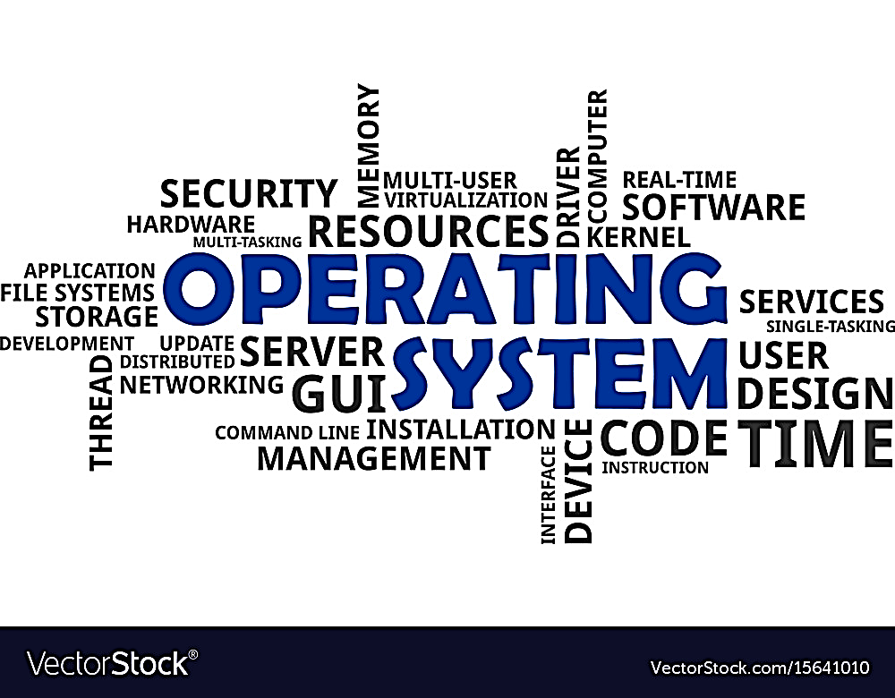

**OS introduction including history and implementation, machine type**

Supervised by

Dr.Yasser Fouad

Contents

1

What’s Operating system and history?

1

Introduction about OS

1-2

History of OS

2

History of FreeBSD

2

WINNING STREAK

35

Serious mistakes

48

Fortune never left me

3

ALONE IN WILDERNESS

58

Bible next to my pillow

70

Waterfall will always remember

4

HAPPY ENDING

83

Never felt so alive until I was so close to death

98

Growing old together

115

Incredible turn of events

122

Who would tell it ends like this

What’s an Operating System?

1

a modern computer consists of one or more processors, some main memory,

disks, printers, a keyboard, a mouse, a display, network interfaces, and various

other input/output devices, but also, how all this will work without something working as

an access point between all of those hardware components and the application of software?

* Operating System Definition: acts as an intermediary between the user of a computer and the computer hardware.
* Purpose? providing an environment in which a user can execute programs in a convenient and efficient manner.
* The example OS readers are a lot, like Windows, Linux, FreeBSD, or even OS X and all of them have their own type of program to interact with it, sometimes called Shell or Bash in Linux, and Windows setting has its own Desktop environment to make it interactable with the user.
* Our main OS for the remaining tasks is FreeBSD, and we will discuss it in detail.

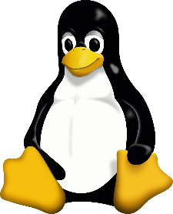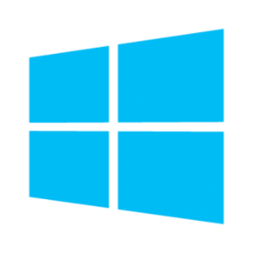

____________________________________________________________________________________________________________

What’s the History of it?

1

|  |  |
| --- | --- |
| Time | Action |
| 1940 : 1950s  vacuum tubes | it was created without any operating system; users have full access to the computer machine and write a program for each task in absolute machine language |
| 1955 - 1965  Transistors and Batch Systems | First OS ever in 1950 called GMOS by IBM  The second-generation operating system was based on a single stream batch processing system |
| 1965 - 1980  Multiprogramming: performing different tasks on a computer at the same time.  Do you know that AMD kind better than intel in multiprocessing ? | In late 1960s, designers were very capable of developing a new operating system that could simultaneously perform multiple tasks in a single computer program called multiprogramming  and in this generation has existed minicomputer which was its name is DEC PDP-1 |
| 1980 - Present Day  Personal Computers | Generally, development of Personal Computers, is very similar to the minicomputers that were developed in the third-generation, was very high cost this time  The major factor this time was birth of Microsoft with their Windows by 1975, as they first MS-DOS was introduced at 1981 with dificullty sure to make simple human understand it  Then it upgraded to windows 95, then 98, and XP which was so popular this time, with 10 versions and last one is 11 by 2021 |

____________________________________________________________________________________________________________

What about FreeBSD?

FreeBSD introduced first early 1993, it was the brainchild of the unofficial OS 386BSD it was Bill Jolitz’s OS, which had been up to that point suffering rather severely from almost a year’s worth of neglect.

The first distribution of was FreeBSD 1.0 in 1993

The Goal of this FreeBSD that to provide software that may be used for any purpose and without strings attached.

Add to that the very open and flexible process of its development, being literally built from the contributions of thousands of people around the world as a great Open-source OS.

FreeBSD offers a ported software collection with thousands of commonly sought-after programs.

There are about 36000 ports; the entire Ports Collection requires approximately 3 GB.

Almost every port is also provided as a pre-compiled "package", which can be installed with a simple command (pkg install) by those who do not wish to compile their own ports from the source.

2